

**EAST WEST UNIVERSITY**

**Course Title:** Human Computer Interactions

**Course Code:** CSE 428

**Section:** 01

**Project Report**

**Submitted by:**

Name: Shawna Akter

ID: 2023-1-60-071

Name: Rijia Parvin Raya

ID: 2022-3-60-192

Name: Sheikh Sarafat Hossain

ID: 2022-3-60-109

Name: Fahimun Islam Lamia  
ID: 2021-3-60-181

Name: Mahfuz Uddin Ahmed

ID: 2023-1-60-207

**Submitted to:**

Name: Yasin Sazid

Designation: Lecturer

Department of CSE

East West University

**Table of Contents:**

**Chapter 1** **(Introduction)** ...…………………………………………………………………. 1

Project Theme ………………………………………………………………………………... 1

Project Overview …………………………………………………………………………….. 2

Objectives & Scope ………………………………………………………………………….. 4

Stakeholders ………………………………………………………………………………….. 5

**Chapter 2** **(Low Fidelity Sketching**) ……….………………………………………………. 6

Sketches …………………………………………………………………………………….... 6

**Chapter 3** **(Background Study)** …………………………………………………………… 19

Accessibility-Based Screen Interaction ……………………………………………………... 19

Misinformation Warning UI Design ………………………………………………………… 20

Real-Time On Device Detection …………………………………………………………….. 20

User Perception & Trust …………………………………………………………………….. 21

**Chapter 4** **(User Research)** ………………………………………………………………… 22

Research Questions Development ………………………………………………………….. 22

Interview Questionnaire …………………………………………………………………….. 23

Alternate or Complementary Research Method …………………………………………….. 24

Data Collection …………………..………………………………………………………….. 25

**Chapter 7** **(Product Development)** ………………………………………………………… 33

Technologies Used …………………………………………………………………………… 33

System Architecture ………………………………………………………………………….. 34

Model Integration …………………………………………………………………………….. 35

Development Progress ………………………………………………………………………... 36

**Chapter 8** **(Conclusion)** ……………………………………………………………………… 37

Learnings ……………………………………………………………………………………… 37

Limitations …………………………………………………………………………………….. 37

Future Plan …………………………………………………………………………………….. 38

# **CHAPTER 1 — INTRODUCTION**

## **Project Theme: Fake News and Virality on Social Media**

Misinformation and fake news spread rapidly on social media, influencing public

perception and decision-making. The viral nature of fake news can have serious

consequences, including political polarization, public health misinformation, and societal

distrust. Addressing this issue requires designing interventions that help users critically

evaluate information, recognize misinformation, and promote responsible sharing habits

in social media.

Our team’s goal is to choose a specific user group and design a product or system that

empowers them to detect, analyze, and mitigate the spread of fake news. We may

target relevant user groups such as high school students, social media influencers,

elderly internet users, or journalists. However, we encourage you to pick a user group

you are not part of to minimize personal bias in research and solution design.

Over the course of the semester, our team will work on designing a system that helps

users become more media-literate and make informed decisions when engaging with

online content. Our solution should not only provide a means to identify fake news but

also encourage critical thinking and responsible online behavior.

It will be important to define the following:

● Who are the users affected by fake news?

● What are the key platforms where fake news spreads?

● What are the psychological and social factors that contribute to the virality of

misinformation and fake news?

● What are the assumed challenges in addressing fake news?

Some broad directions:

● Media Literacy Tools (e.g., browser extensions, AI-powered fact-checkers,

educational games)

● Community-Driven Solutions (e.g., reporting mechanisms, misinformation

awareness campaigns)

● Algorithmic and Technical Interventions (e.g., detecting and flagging fake

news, credibility scoring systems)

During this course, our team will need to conduct secondary research to understand

how misinformation spreads and conduct qualitative research to identify first-hand

experiences with fake news. This includes interviewing users, fact-checkers, or

professionals working in media literacy.

As part of our project, we will need to define the specific needs of our chosen user

group and design an intervention that helps mitigate misinformation. While our design

may not completely eliminate fake news, consider how existing technology supports or

fails to address this issue and propose an improved solution.

We encourage you to consider the intersectional aspects of misinformation—how

factors such as age, education, socio-economic status, and digital access influence how

people engage with fake news. Be specific in the community and users we select!

Addressing a well-defined group allows for a deeper understanding of their challenges

and how our solution can effectively support them.

Critical Considerations:

● Keep an open mind when researching the challenges of misinformation.

● Select a user group that you are either not part of or can remain neutral towards.

● Choose a local community that you can access for research and interviews.

● Explore innovative solutions beyond simple fact-checking apps.

## **Project Overview (Based on Our Actual System & Code)**

ShottyoBondhu is an Android application that we developed using several interconnected components:

### **1. Accessibility Service (ShottyoBondhuService)**

Our AccessibilityService:

* Reads screen content using accessibility events
* Identifies text nodes and extracts them for potential analysis
* Manages our overlays through WindowManager as implemented in our Java service

### **2. Floating Warning Widget**

Using layout_floating_widget.xml, we designed:

* A red cyberpunk alert panel
* tvAlert which displays “FAKE NEWS”
* btnClose to dismiss the alert

This widget is dynamically inflated in our service whenever suspicious content is detected.

### **3. Highlighter Overlay**

Based on layout_highlighter.xml, we implemented:

* A transparent fullscreen overlay
* A glowing red border using border_red.xml

This overlay visually marks the area of concern on the screen.

### **4. Main Permission Dashboard**

Our activity_main.xml dashboard displays:

* System Status (Offline / Online)
* Overlay Permission Status
* Accessibility Permission Status

Users must enable these permissions before the detection system can operate.

Once permissions are granted, the service begins scanning on-screen text and displaying real-time visual warnings. This workflow aligns with the components and structure we built in our project.

## **Objectives and Scope (Based on Our Implementation)**

### **Primary Objectives**

* Implement a working AccessibilityService capable of extracting screen text
* Provide real-time misinformation detection alerts via overlays
* Create a unique cyberpunk visual identity using custom drawables such as:  
  + bg_cyberpunk_alert.xml
  + bg_cyberpunk_button.xml
  + bg_cyberpunk_card.xml
* Highlight suspicious content using fullscreen highlighter overlays
* Ensure our system works across multiple apps like social media and browsers

### **Scope**

**Included in the current project:**

* Accessibility text extraction
* Floating cyberpunk alert overlay
* Highlighter frame overlay
* Permission management UI
* Basic placeholder detection logic ready for ML integration

**Excluded from our current scope:**

* Full server-based fact-checking pipelines
* Multimedia misinformation detection
* Browser extensions or desktop implementations

## **Stakeholders**

### **Primary Stakeholders**

* Everyday smartphone users exposed to misinformation
* Students, researchers, and elderly users who may need on-screen assistance

### **Secondary Stakeholders**

* Developers who contribute to or maintain the system
* Digital literacy educators
* Fact-checking organizations

### **Institutional Stakeholders**

* Course instructors evaluating our HCI project
* University committees involved in academic research supervision

### **Ethical Stakeholders**

* Users concerned about privacy, since an AccessibilityService can read on-screen text

# **CHAPTER 2 — Low Fidelity Sketching**

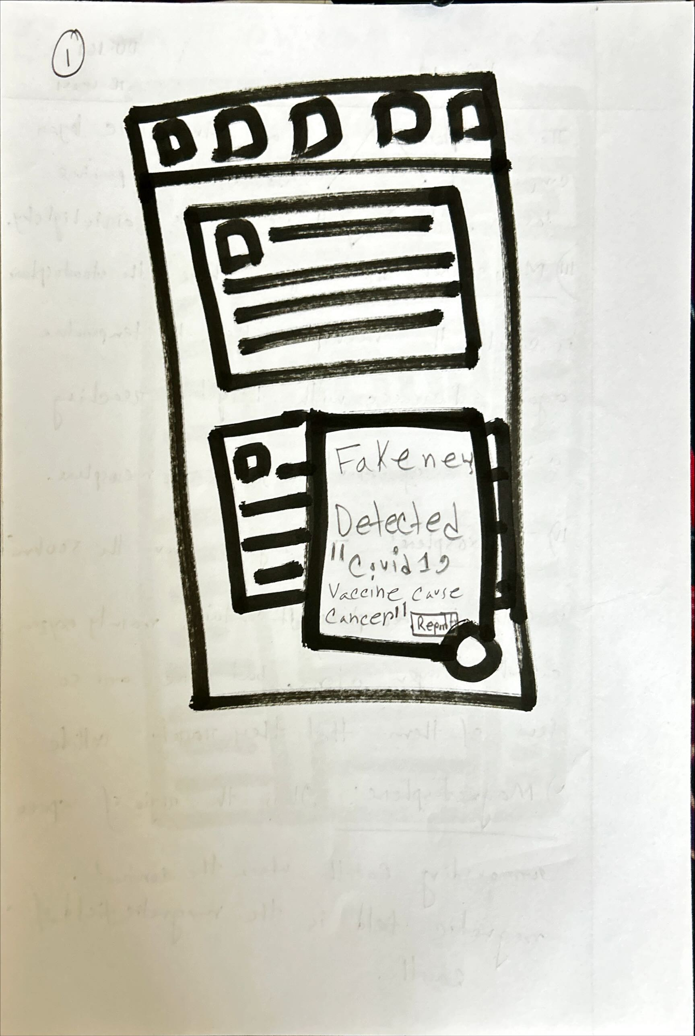

**Mobile App Bot:** This theme is about a bot within a mobile app designed to interact with users. It allows users to quickly send messages, ask questions, and get replies. The design emphasizes simple, accessible communication through an intuitive interface.

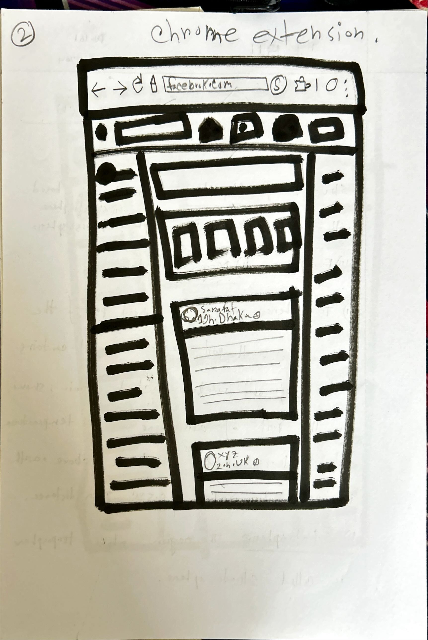

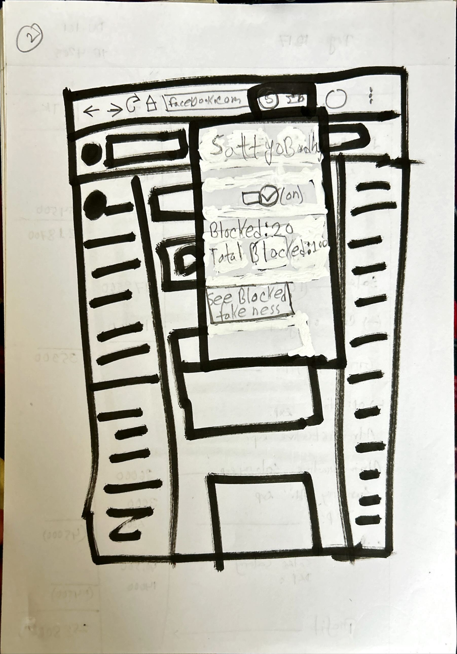

**Chrome Extension:** This theme shows the concept of a Chrome extension for blocking fake news. It overlays a toolbar that users can interact with while browsing. It provides an easy way to flag and manage fake news detection as users browse social media and other websites.

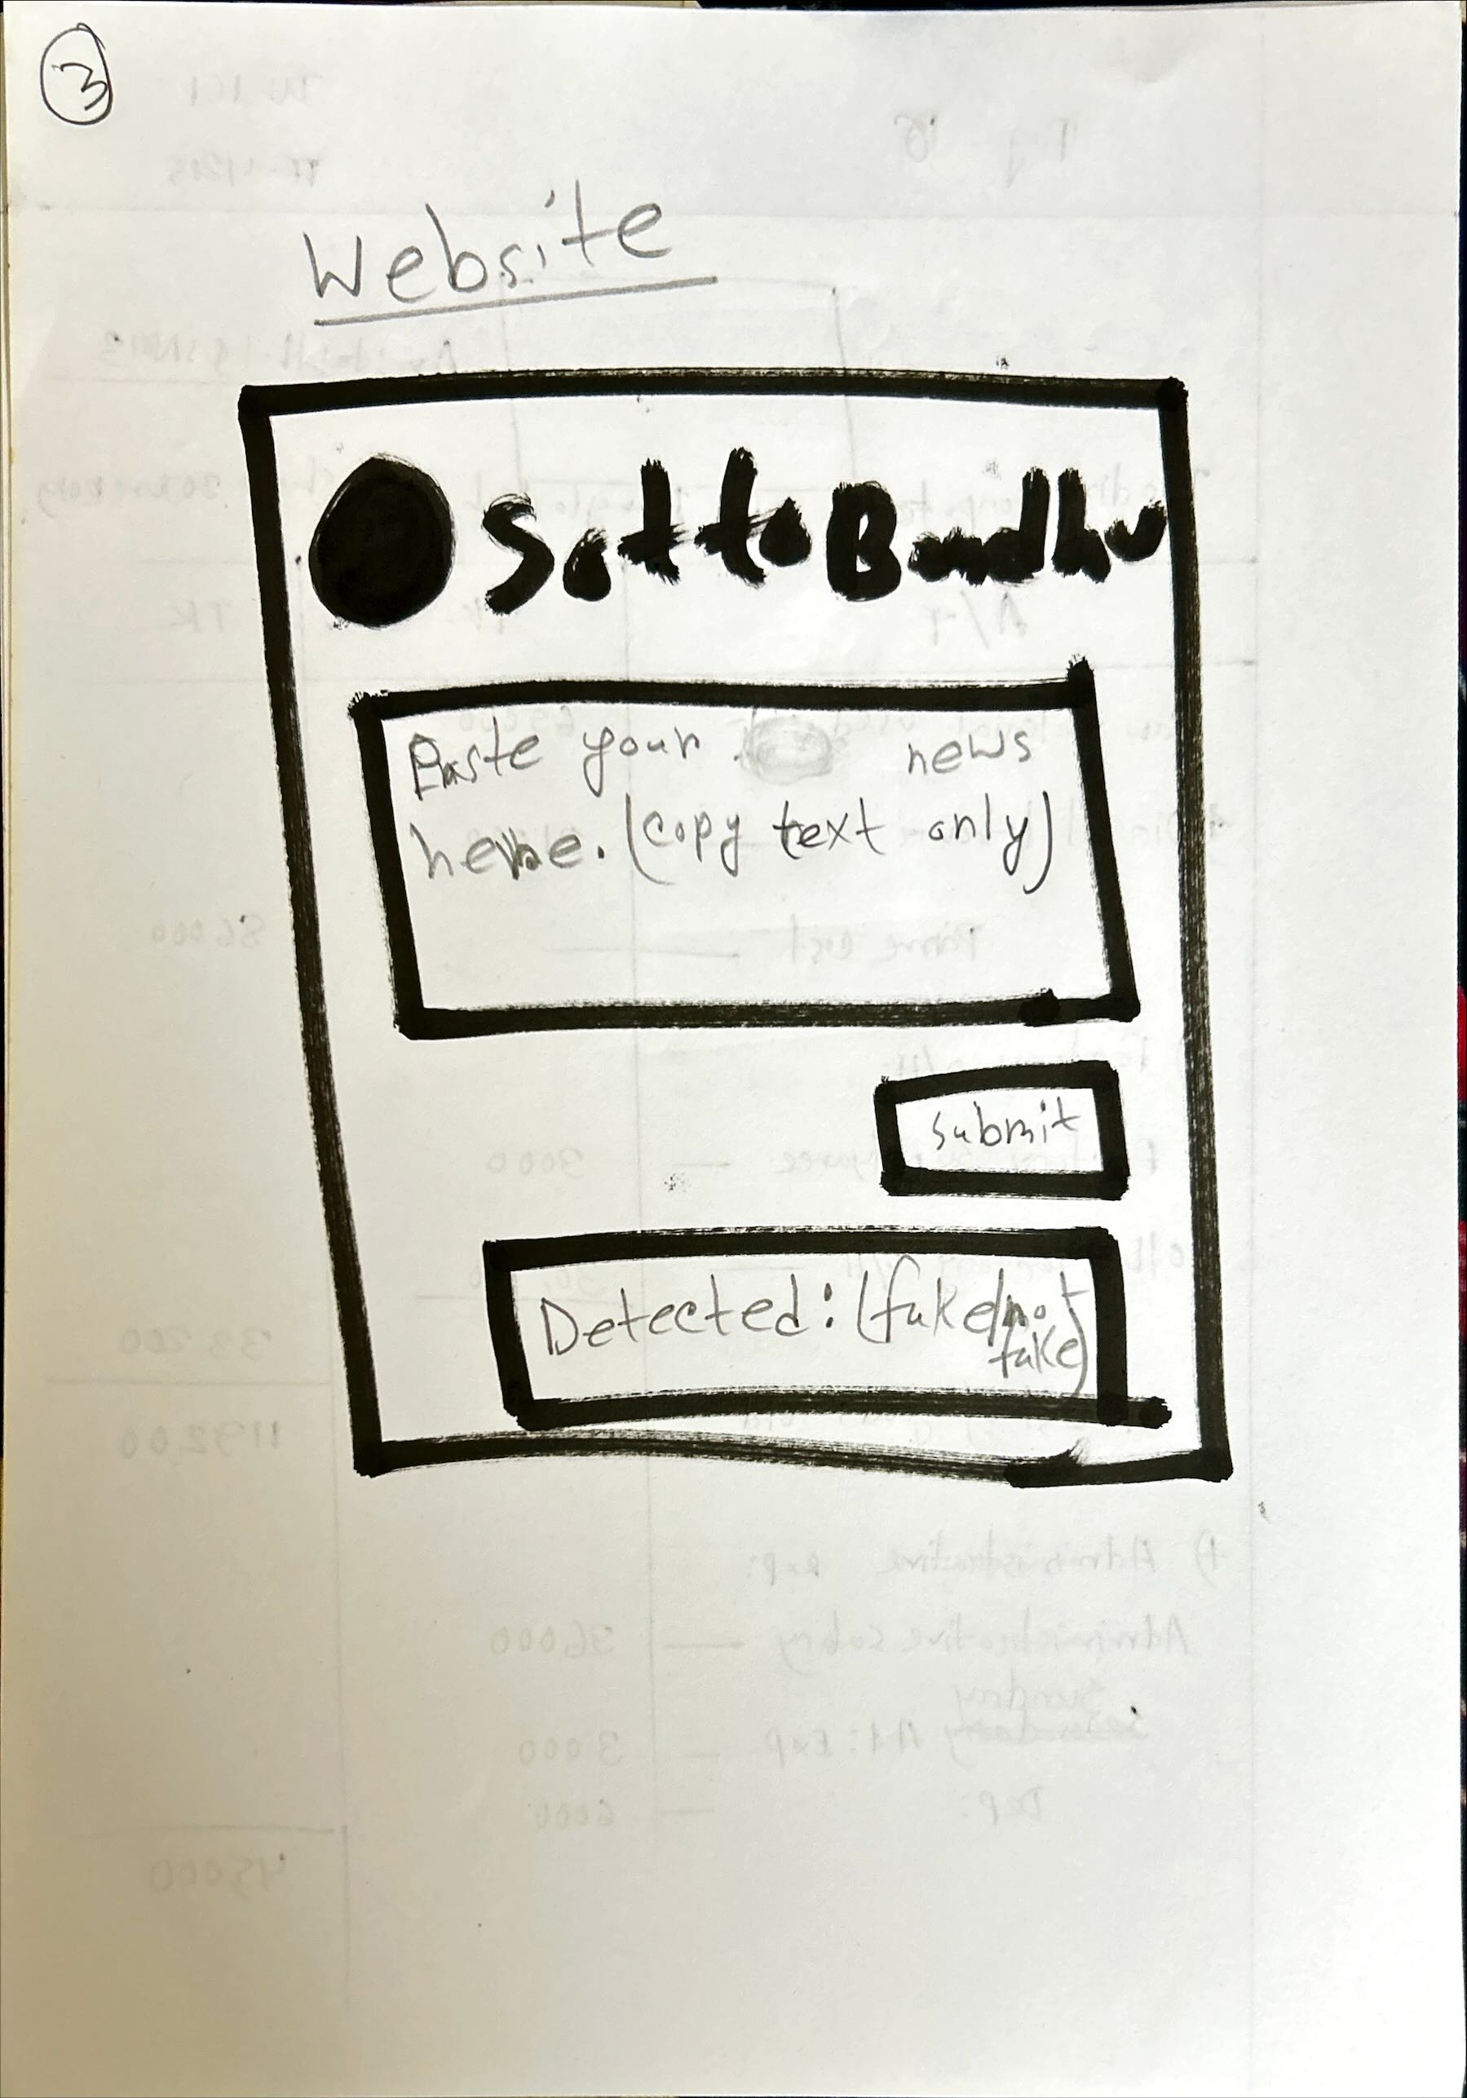

The sketch represents a website called "SottoBandhu" designed for fake news detection. Users can paste news text into the provided box, and after clicking "Submit," the website checks the news for authenticity, displaying whether it is "fake" or "true."

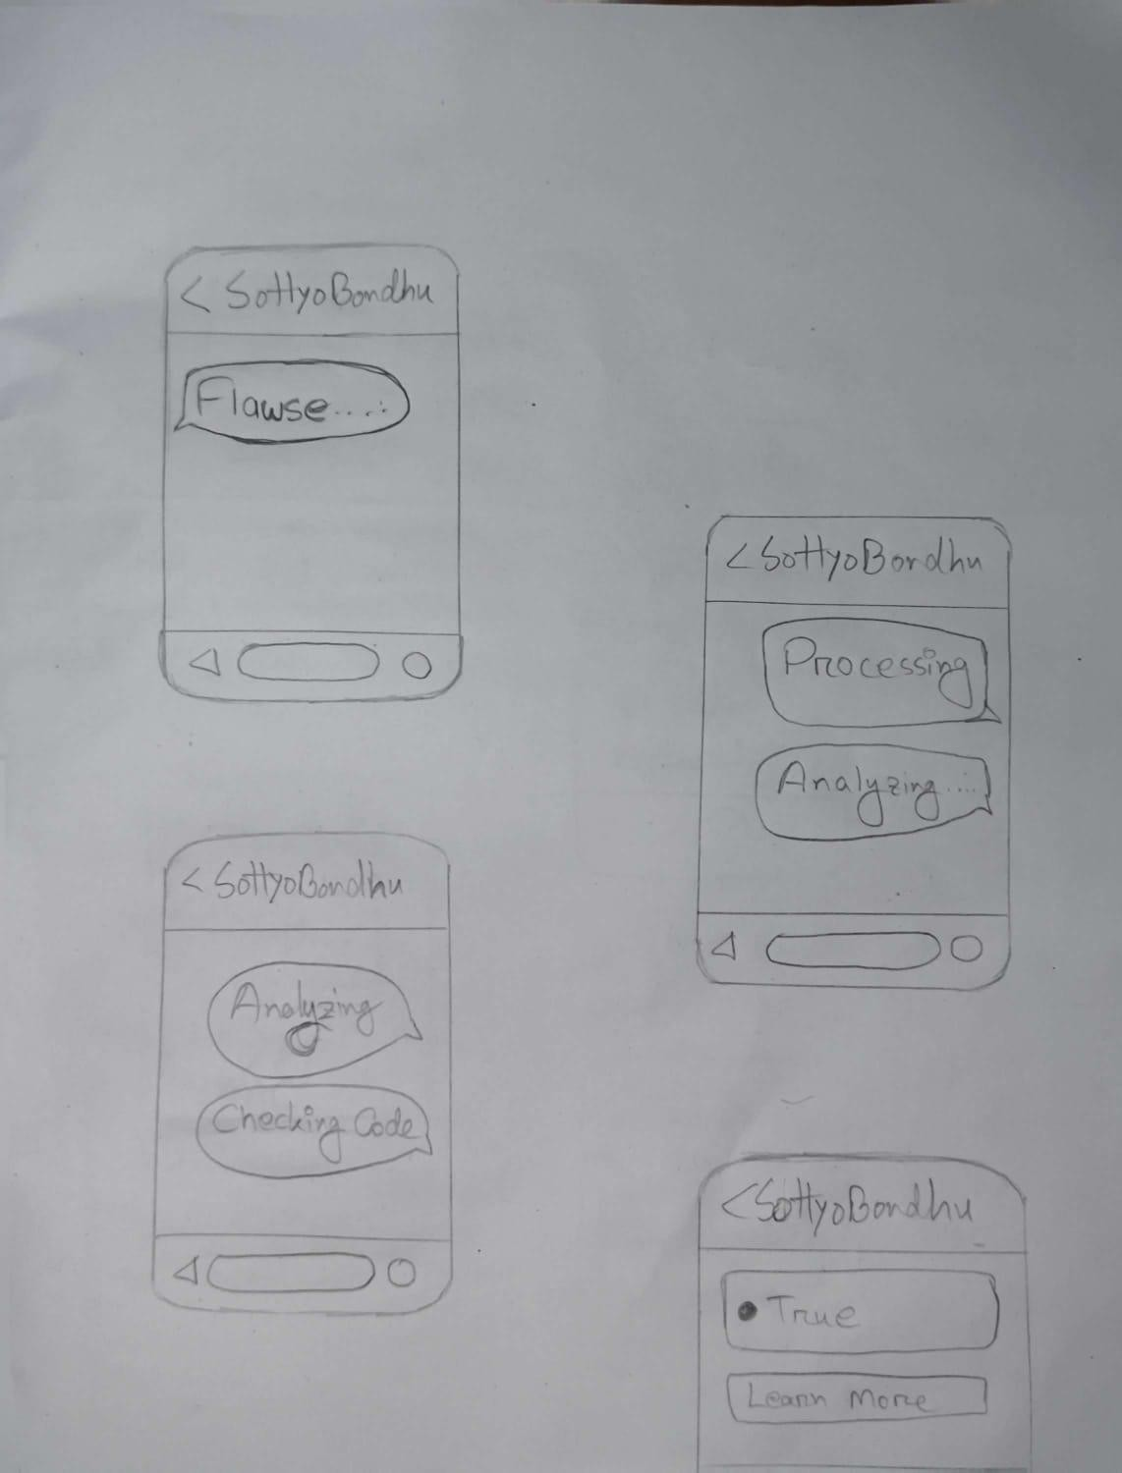

This sketch shows the process flow of the "SottoBandhu" mobile app for fake news detection:

1. **Flawse**: The app starts by identifying potential flaws or issues in the news content.
2. **Processing**: The app processes the text to analyze it for authenticity.
3. **Analyzing and Checking Code**: It then analyzes the content, checking against various algorithms or databases to detect fake news.
4. **Result**: Finally, the app provides the result, showing whether the news is "True" and offering an option to "Learn More" for further details.

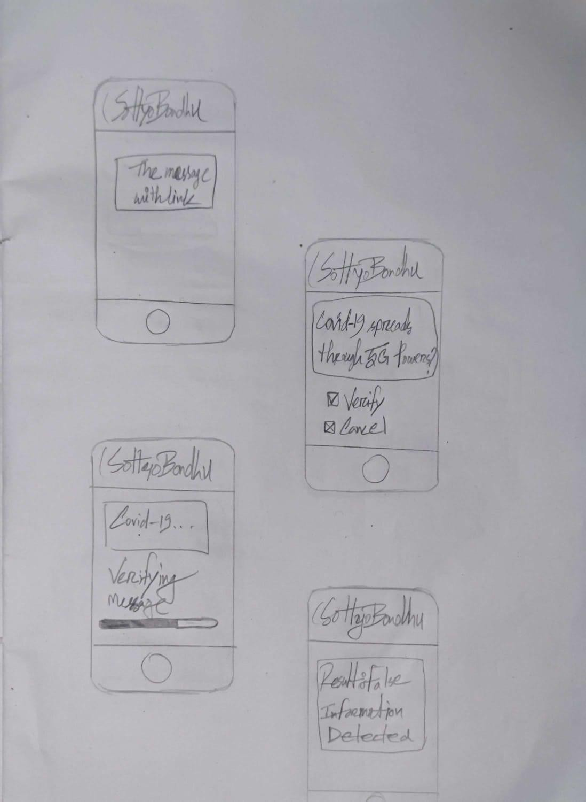

This sketch shows the verification process in the "SottoBandhu" app:

1. **Message with Link**: The app displays a message containing a link that needs verification.
2. **Verification Option**: Users are given the option to verify or cancel the verification process.
3. **Verification in Progress**: The app processes the news content, indicated by a "verifying" message and progress bar.
4. **Result**: After verification, the app displays the result, showing if the information is "True" or "False" with a "Fake News Detected" message.

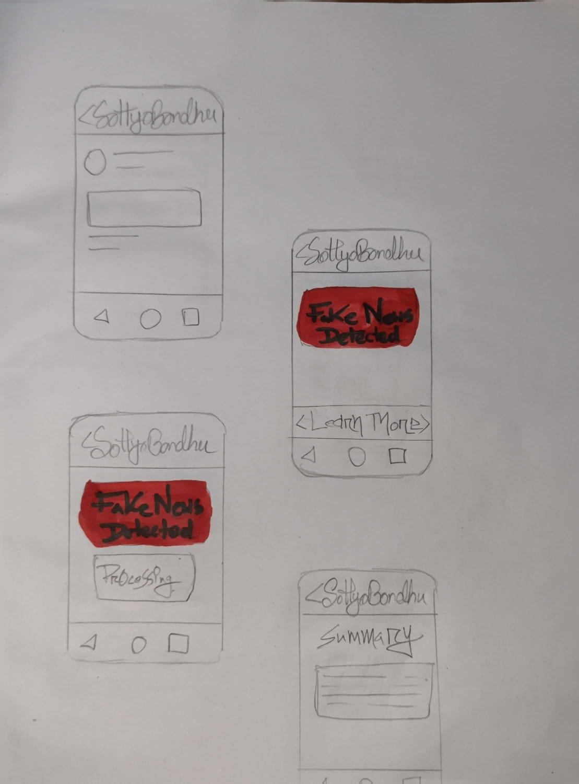

This sketch illustrates the fake news detection process on the "SottoBandhu" mobile app:

1. **Paste News**: Users paste news text for verification.
2. **Fake News Detected**: The app shows a red warning message, "Fake News Detected," indicating the news is false.
3. **Processing**: The app is processing the information, shown by a "processing" label.
4. **Summary**: After the analysis, the app provides a summary, which gives more details about the fake news detection.

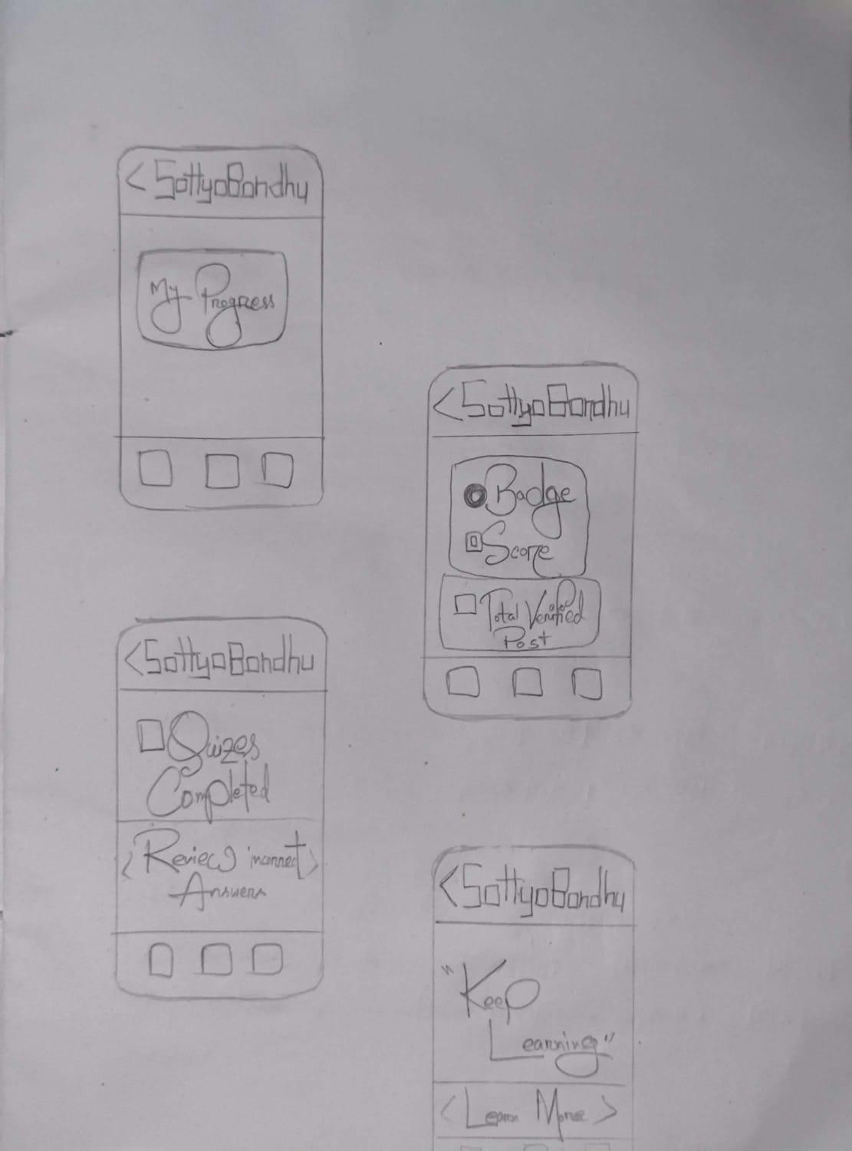

This sketch shows the user progress and engagement flow in the "SottoBandhu" app:

1. **My Progress**: The first screen displays the user’s progress, where they can track their activities.
2. **Badges and Scores**: It shows the badges earned and the user's score, including the total number of verified posts.
3. **Quizzes Completed**: This screen shows the quizzes completed by the user, with an option to review answers and performance.
4. **Motivational Message**: The final screen encourages users with a "Keep Learning" message, motivating them to continue engaging with the app.

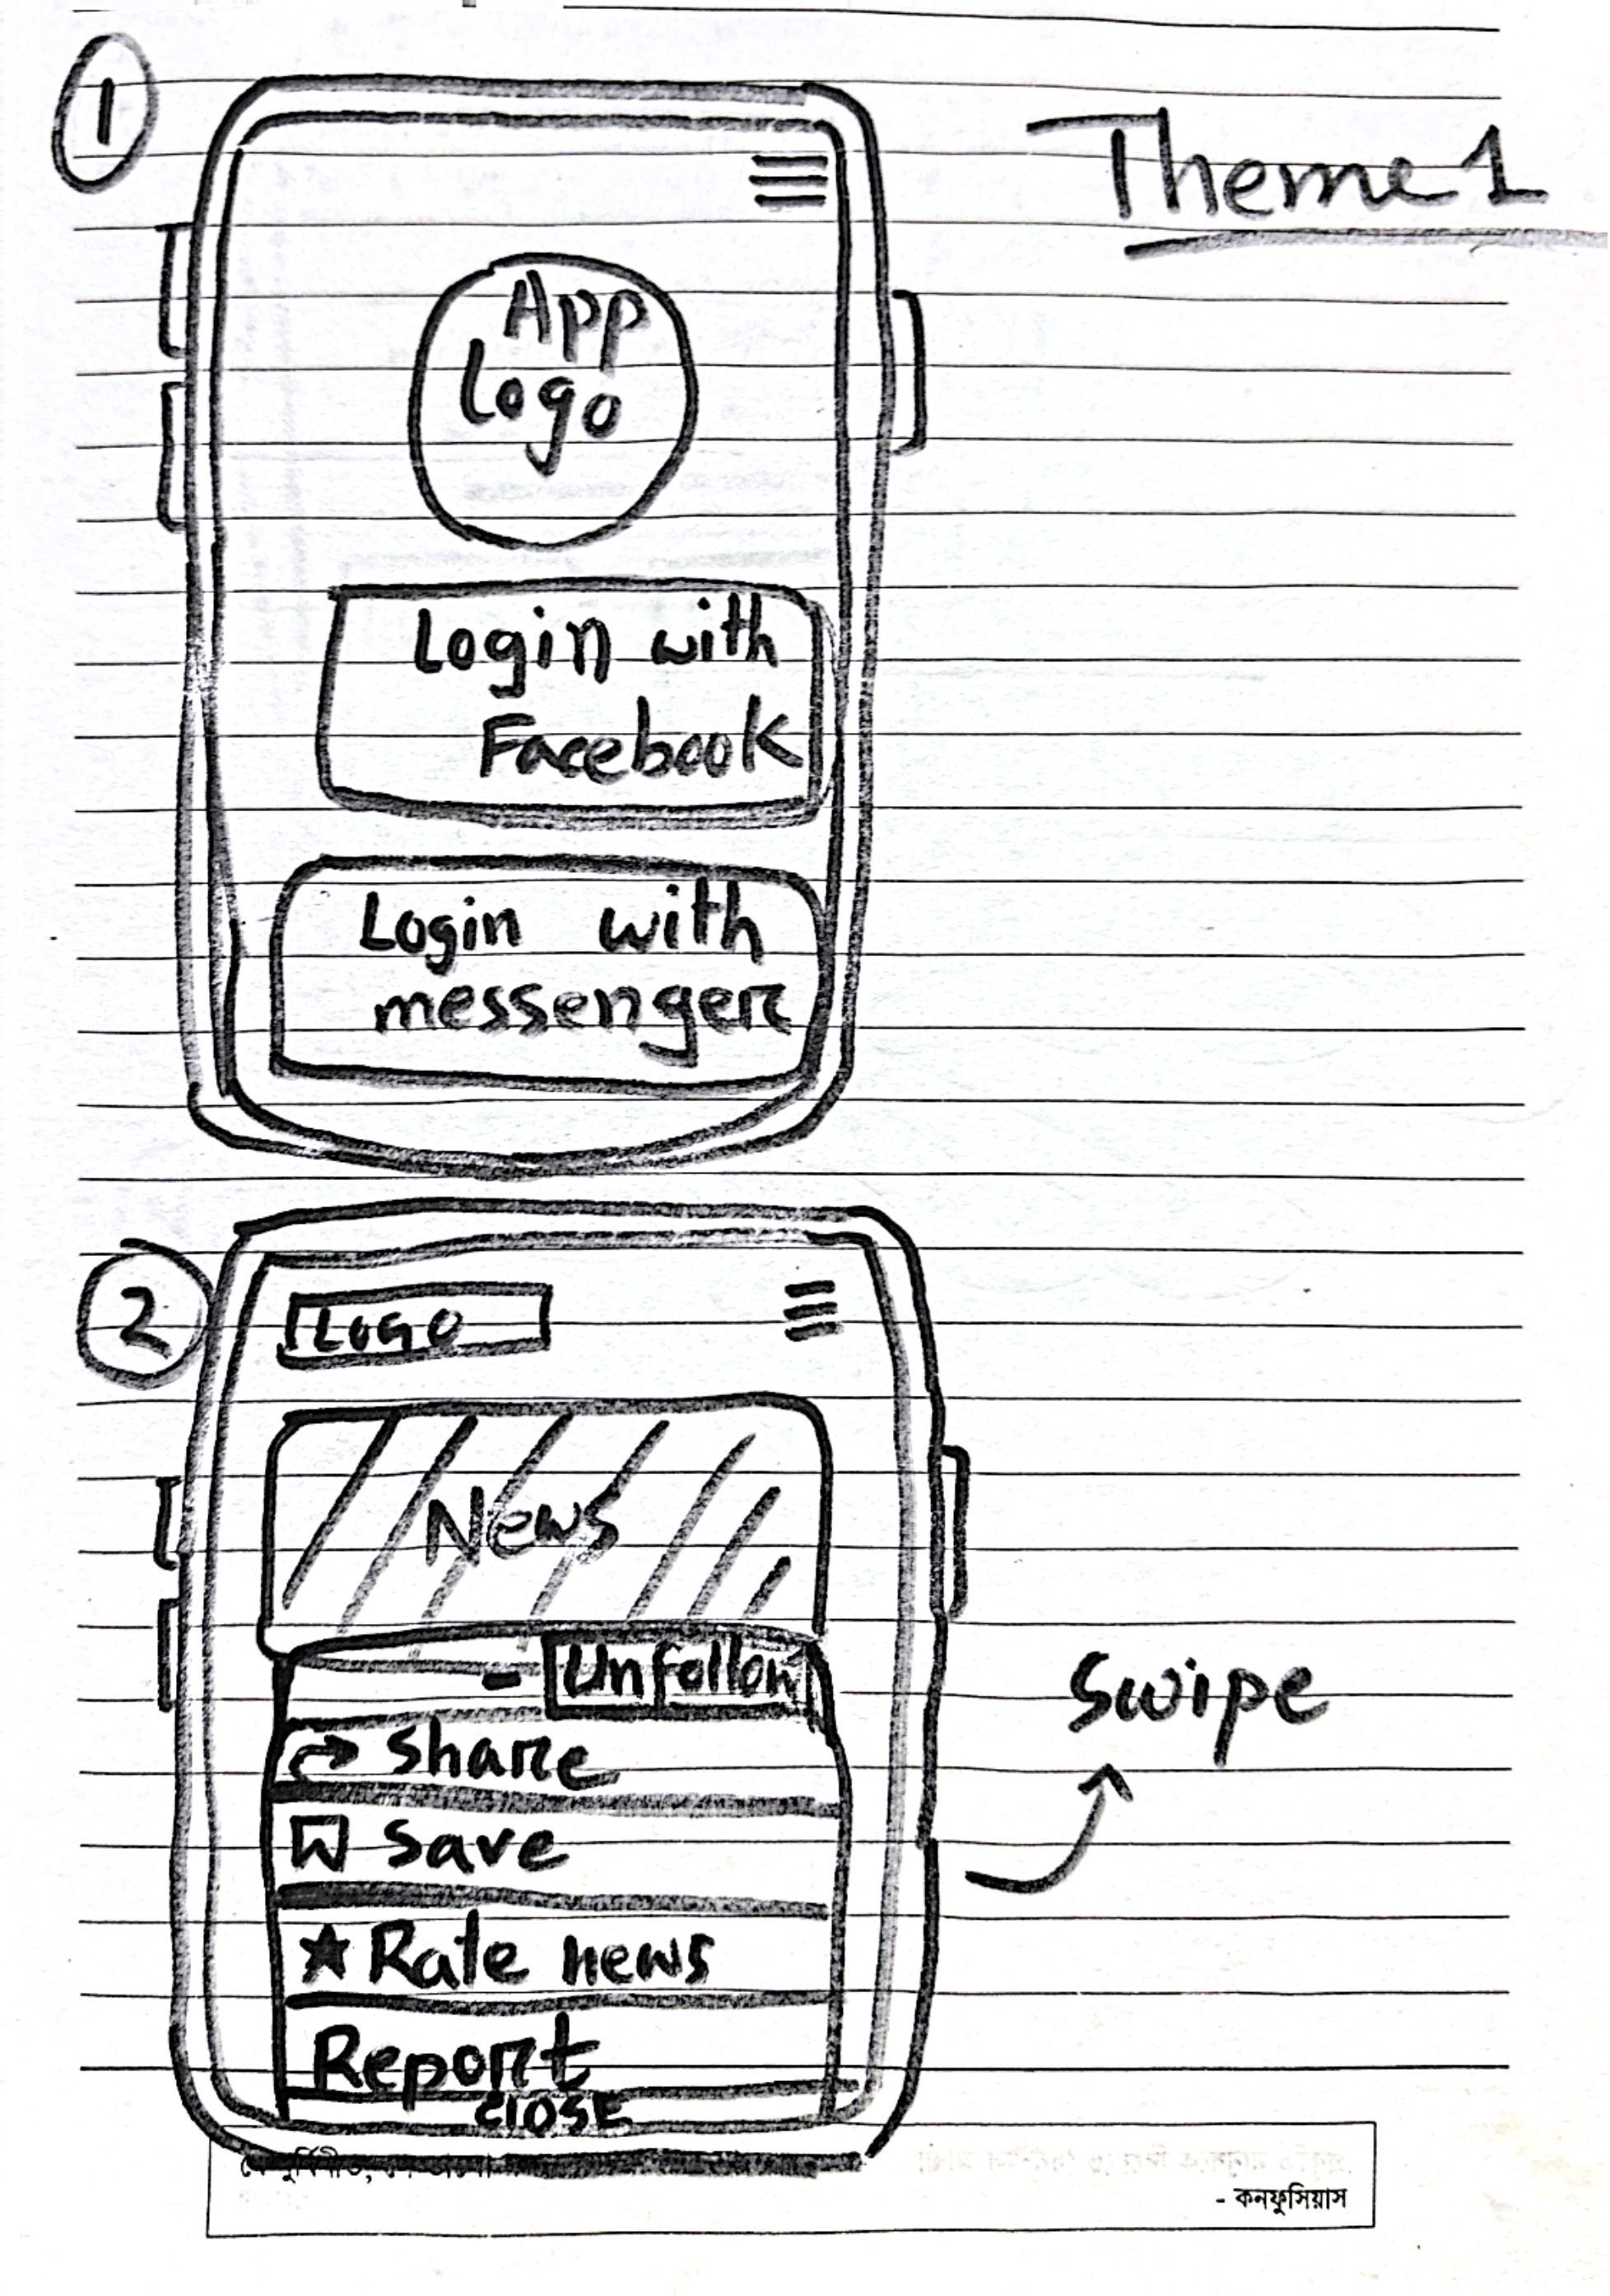

The sketch represents the user interface for the "SottoBandhu" app:

1. **Login Screen**: The first screen shows the app logo with options to log in using Facebook or Messenger. This allows users to quickly access the app using existing credentials.
2. **News Feed**: After logging in, users are directed to the news feed. Each news item comes with several interactive options:
   * **Unfollow**: Users can choose to unfollow a particular news source.
   * **Share**: Allows users to share the news on other platforms.
   * **Save**: Users can save the news for later viewing.
   * **Rate News**: A feature to rate the authenticity or importance of the news.
   * **Report**: If the news is fake, users can report it.
3. **Swipe Feature**: The design allows users to swipe through different news items, providing a smooth and engaging way to interact with the content.

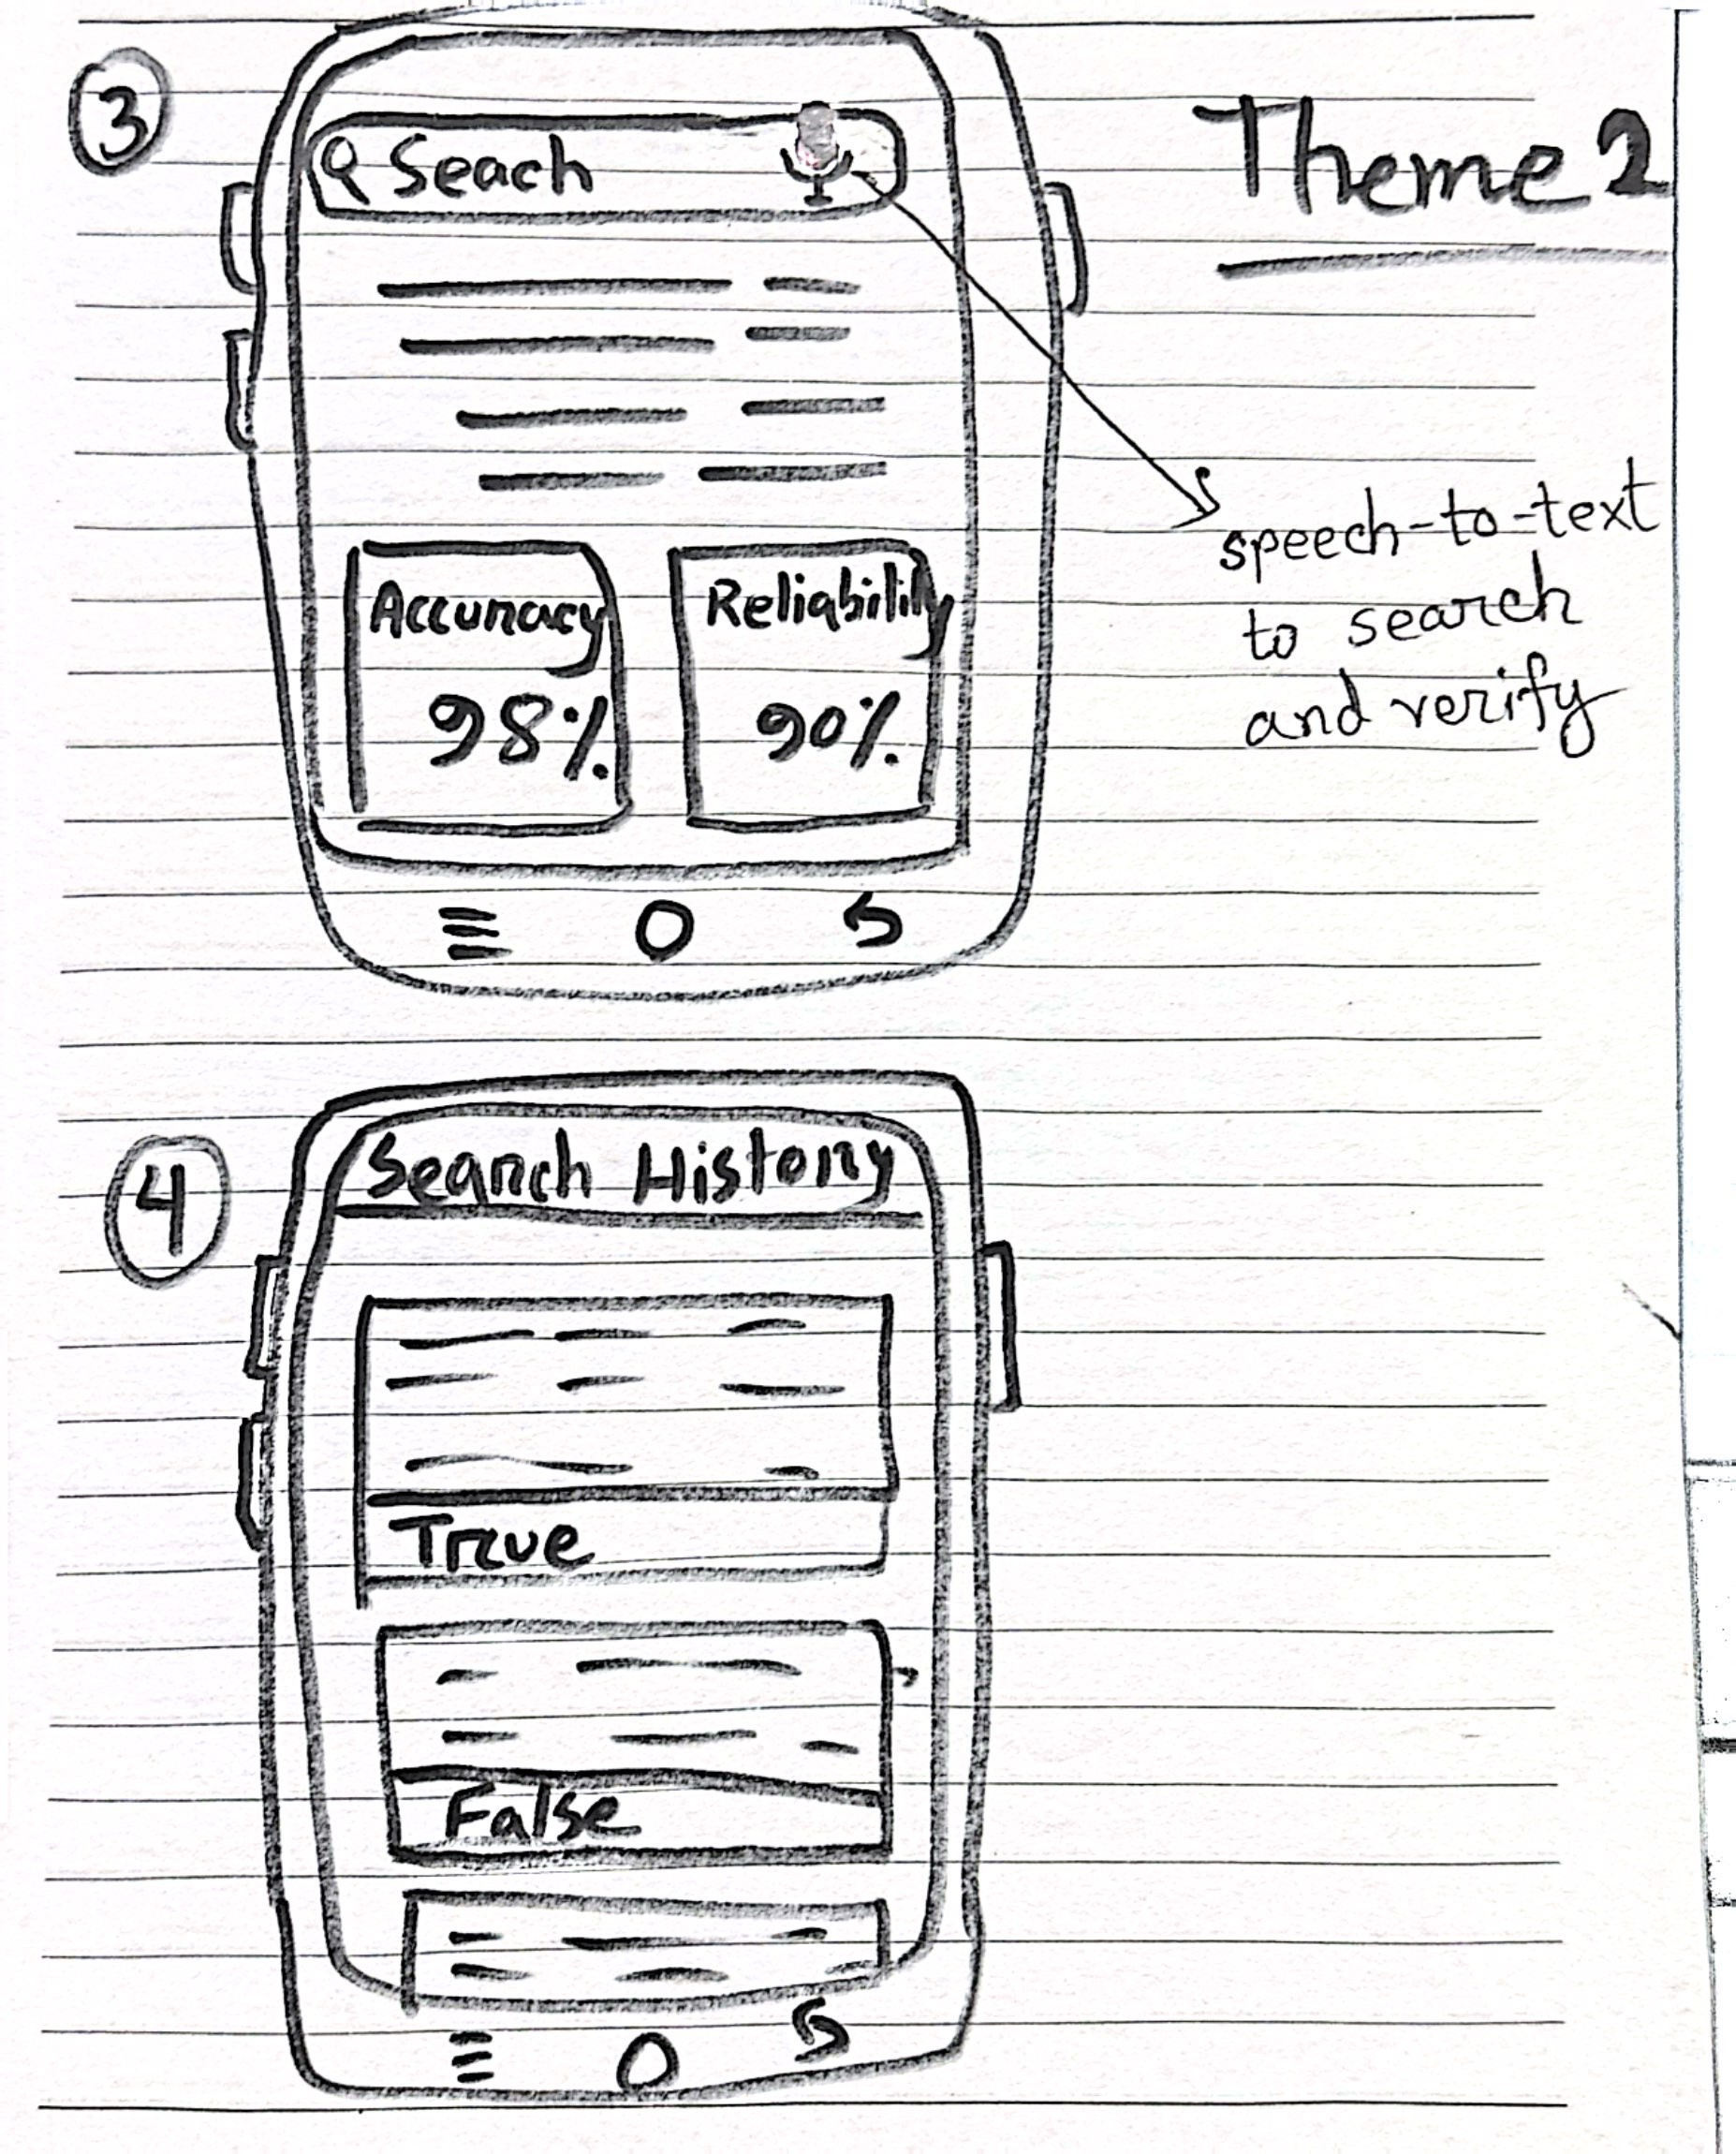

This sketch shows the "SottoBandhu" app's search and history features:

1. **Speech-to-Text Search**: Users can speak to search and verify information. The app displays accuracy (98%) and reliability (90%) scores for the search results.
2. **Search History**: This screen shows past searches, categorized by "True" or "False" to help users track previously verified news.

The design highlights easy, voice-enabled searching and keeps track of news verification results.

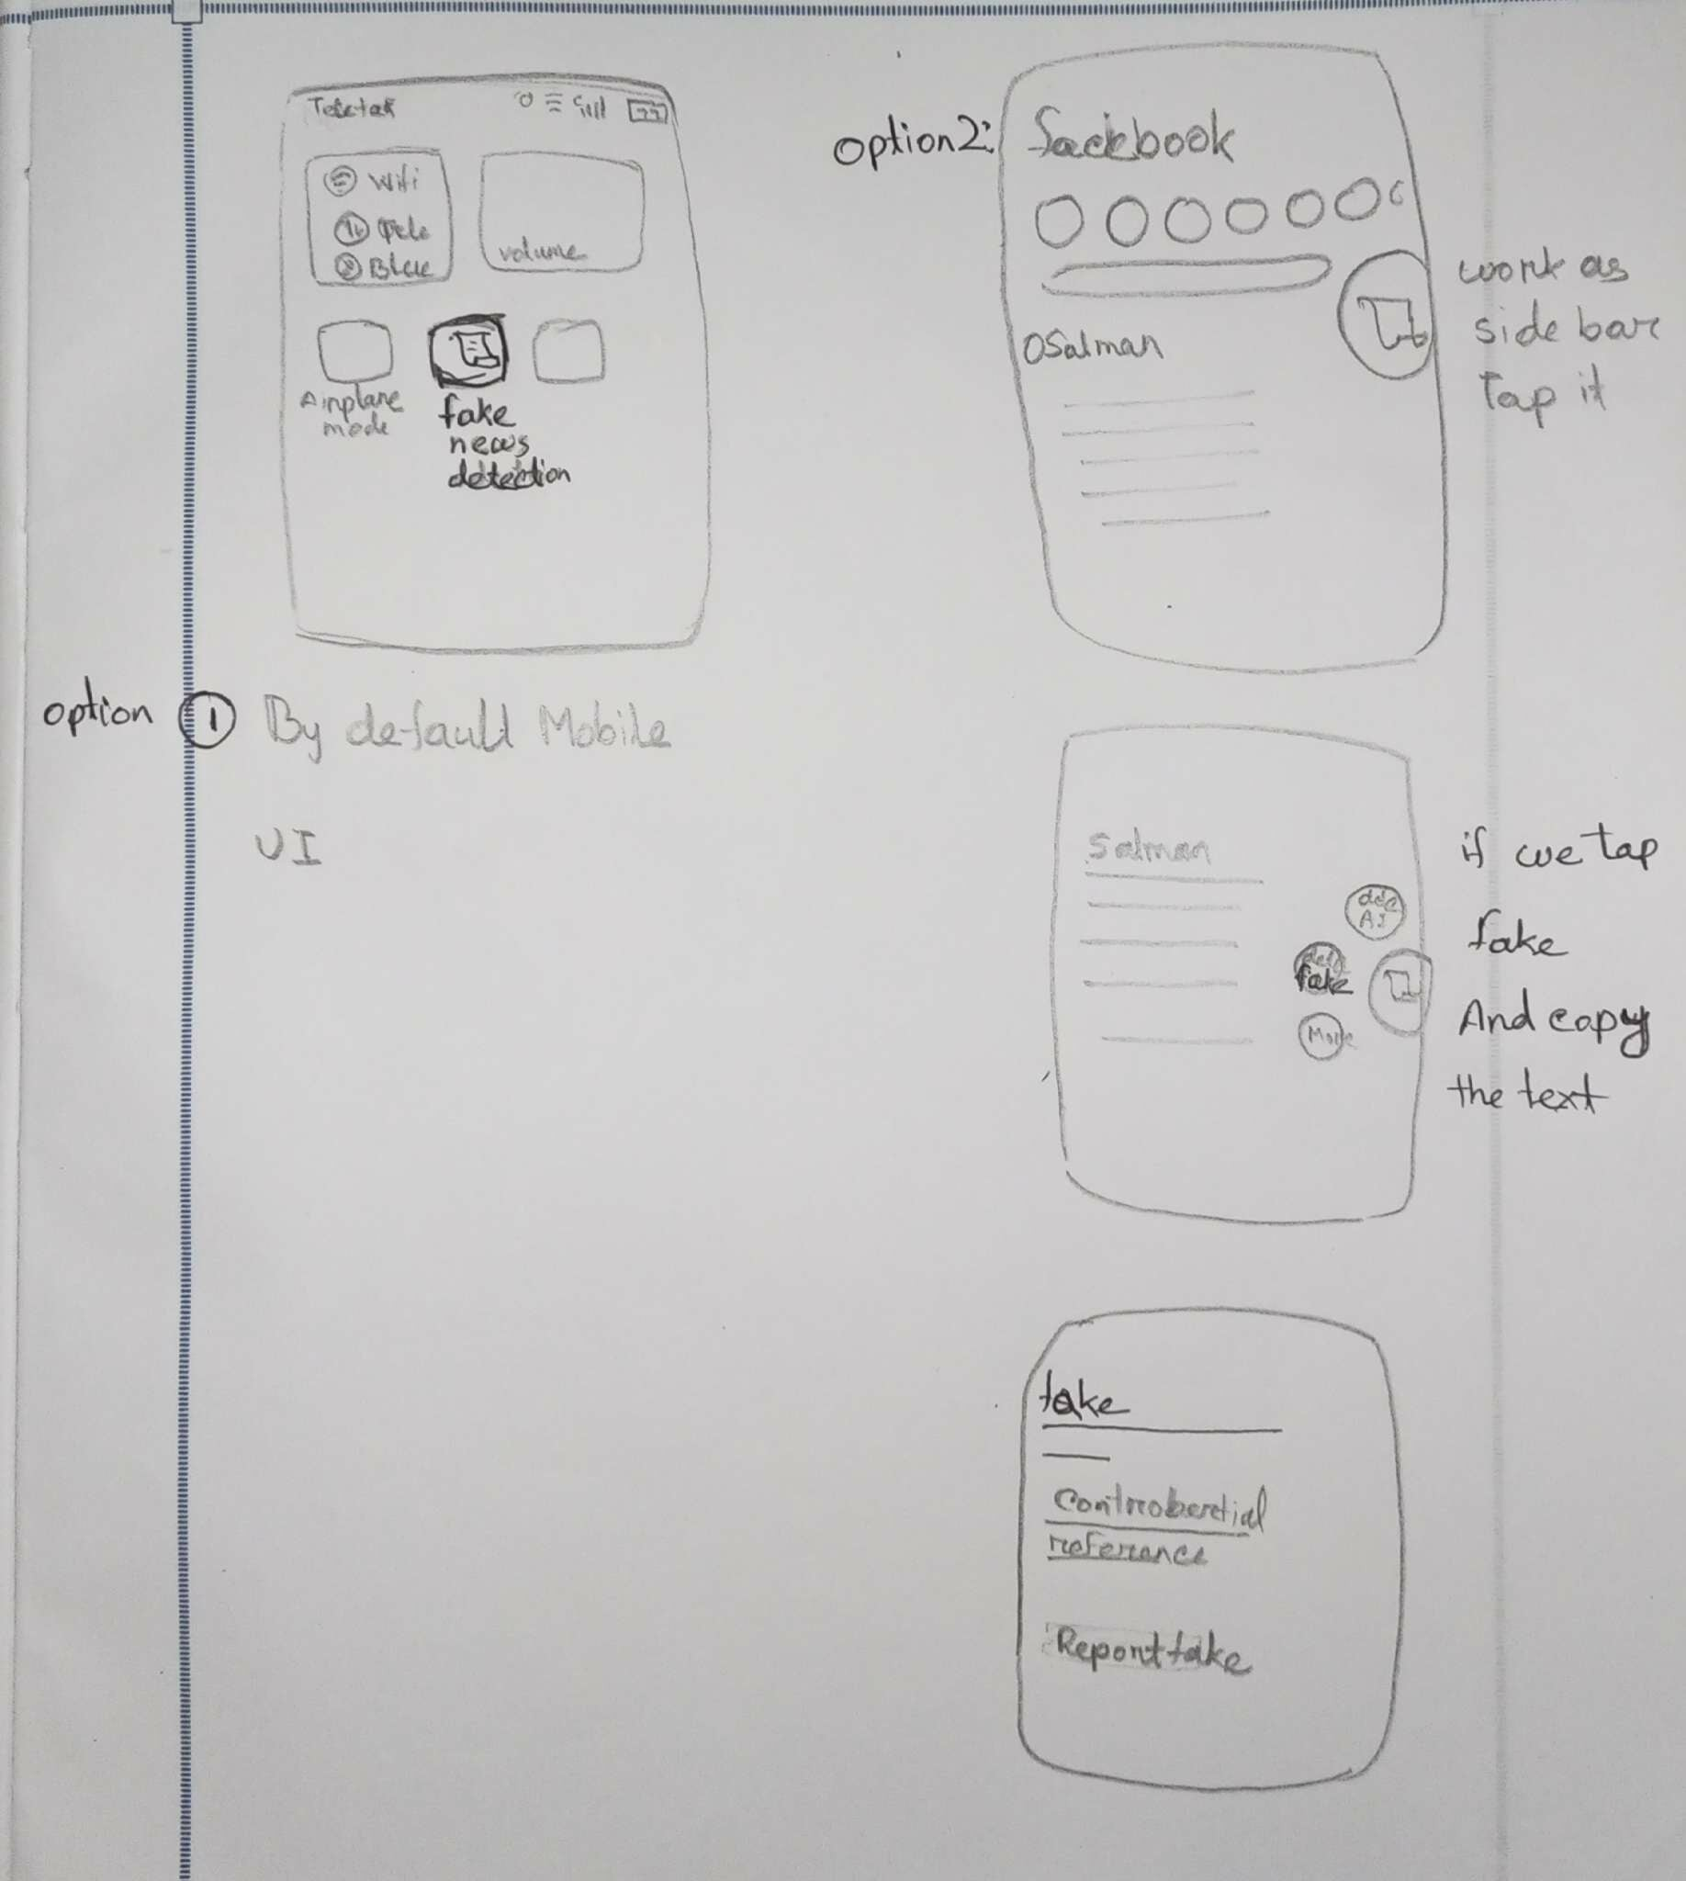

This sketch illustrates two options for using the "SottoBandhu" app:

1. Default Mobile UI: The app's main interface includes a "Fake News Detection" button. It allows users to easily access the fake news detection feature while using the phone normally.
2. Facebook Integration: The app works as a side toolbar when using Facebook. Users can tap on a "Fake" button to detect fake news and copy the text for further verification.

Once fake news is detected, the app provides options to check sources, report the fake news, or view more details about the misinformation.

# **CHAPTER 3 — BACKGROUND STUDY**

This background study connects our actual implementation—AccessibilityService, overlays, cyberpunk UI elements, and permission flows—to relevant HCI and misinformation research.

## **3.1 Accessibility-Based Screen Interaction**

Our system relies on Android’s AccessibilityService and our configuration file service_config.xml to:

* Retrieve screen text
* Listen for window content change events
* Highlight relevant regions

Research on accessibility emphasizes the importance of:

* Using these services responsibly
* Avoiding obstruction of app functionality
* Minimizing cognitive overload with subtle, purposeful alerts

Our system reflects these principles by:

* Using small, dismissible cyberpunk alerts
* Implementing non-blocking overlays via FLAG_NOT_FOCUSABLE
* Ensuring strong visual contrast through our red neon-themed UI

## **3.2 Misinformation Warning UI Design**

HCI research indicates that users respond best to warnings that are:

* Short and clear
* High contrast
* Accompanied by visual cues such as highlight borders
* Free of overwhelming or overly technical language

Our UI reflects this through:

* tvAlert, which uses large, bold typography (“FAKE NEWS”)
* The neon red frame from bg_cyberpunk_alert.xml
* A highlighter overlay that outlines the suspicious content

These decisions align with usability principles such as:

* Visibility of system status
* Recognition over recall
* Aesthetic and minimalist design

## **3.3 Real-Time On-Device Detection**

Our architecture is designed to support real-time, on-device misinformation detection because:

* Accessibility events provide immediate access to screen text
* We can integrate a TFLite ML model at any stage
* On-device ML reduces cloud dependency and maintains privacy

Research supports this hybrid approach, especially for privacy-sensitive use cases like misinformation detection.

Our system already contains all necessary hooks for future ML integration.

## **3.4 User Perception & Trust**

Studies highlight the importance of:

* Minimizing false positives to maintain user trust
* Allowing users to easily enable or disable the system

Our permission dashboard (activity_main.xml) directly addresses these concerns by:

* Showing clear permission statuses
* Providing intuitive buttons for enabling overlay and Accessibility permissions
* Ensuring visibility and transparency of our system’s actions

# **CHAPTER 4 — User Research**

## **4.1 Research Questions Development**

Research Question 1

What factors influence a user's ability to identify fake news on social media platforms like Facebook, WhatsApp, and Messenger?

Motivation:

This question is important to understand how users differentiate between genuine and fake news. It focuses on the elements that users consider while interacting with content, such as the tone, visuals, source credibility, or even the platform's design. The goal is to explore the cognitive factors behind recognizing misinformation and how they could inform the design of a misinformation detection tool.

Participant Information to Collect:

User habits in terms of verifying content before sharing or trusting it.

Perceptions and attitudes towards the effectiveness of existing tools or methods for identifying fake news.

Insights for Design Decisions:

Understanding these factors will help us design a tool that incorporates elements that users rely on for trust, making the tool more intuitive. For example, users might rely on source credibility and visual cues, so TruthMate could prioritize these features in its algorithm or user interface.

Research Question 2

What are the main challenges users face when verifying information on social media, and how can an AI-powered misinformation-checking tool help overcome them?

Motivation:

This question aims to uncover the common barriers or frustrations users experience when trying to verify information, such as lack of tools, time constraints, or difficulty in accessing reliable sources. The goal is to design a tool that addresses these pain points and offers a seamless experience for users to validate the content they encounter.

Participant Information to Collect:

User challenges related to verifying online content (e.g., time, access to reliable sources, or knowledge about verification techniques).

Expectations and preferences for an AI-powered tool to assist with misinformation detection.

Insights for Design Decisions:

By understanding the difficulties users face, we can tailor TruthMate’s features to provide timely, accurate alerts, simple verification steps, and easy-to-understand content verification. Insights could also guide the design of user interfaces that make the verification process less time-consuming and more reliable.

## **4.2 Interview Questionnaire**

1. When you scroll through social media, what signs do you personally look for that make a post feel “not quite right” or questionable?

2. Can you recall a moment when you believed something online and later found out it was false? How did that realization affect you?

3. What influences your decision to trust one piece of online information over another? (tone, visuals, source, comments, etc.)

4. When you come across conflicting information about the same topic, how do you decide which version to believe?

5. In situations where you feel unsure about a post, what stops you from taking the time to verify it?

6. How does the behavior of people around you (friends, family, or peer groups) shape the way you judge online information?

7. What are the most frustrating or confusing parts of trying to verify something online on your own?

8. If you imagine the ideal misinformation-detection tool, what would the tool do before, during, and after you view suspicious content?

9. What would help you personally feel confident that an AI-powered tool (like TruthMate) is accurate, fair, and worth trusting?

## **4.3 Alternate or Complementary Research Method**

1. Age range:

◯ 10–17 ◯ 18–25 ◯ 26–40 ◯ 41–55 ◯ 56+

2. Platforms used:

◯ Facebook ◯ WhatsApp ◯ Messenger ◯ YouTube ◯ TikTok ◯ Others (please

specify): ___________

3. Frequency of social media use:

◯ <1h/day ◯ 1–3h/day ◯ 3–5h/day ◯ >5h/day

4. Primary device used:

◯ Mobile ◯ Tablet ◯ Laptop ◯ Desktop

5. Describe a recent instance when you encountered misleading information online.

____________________________________________________________

6. What is the main difficulty you face when verifying posts

____________________________________________________________

7. What features should a misinformation-checking tool include?

____________________________________________________________

8. How would you prefer the tool to notify you about suspicious content?

____________________________________________________________

9. What kind of support or guidance would help you handle fake news better?

____________________________________________________________

10. Which factor influences belief in fake news most?

◯ Emotional content ◯ Attractive headlines ◯ Peer sharing ◯ Source credibility

11. How confident are you in detecting fake news?

◯ Very low ◯ Low ◯ Moderate ◯ High ◯ Very High

12. Would you use an AI tool to detect misinformation?

◯ Yes ◯ No ◯ Maybe

13. Preferred alert style from a verification tool?

◯ Red ◯ Yellow ◯ Green indicator ◯ Audio alert ◯ Text explanation ◯ Short pop-up

14. What motivates you to verify posts?

____________________________________________________________

15. Share one idea that could make verification tools more user-friendly.

____________________________________________________________

16. Would you prefer text, audio, or visual explanations in the tool?

◯ Text ◯ Audio ◯ Visual ◯ Combination

## **4.4 Data Collection**

Summarization of the survey data:

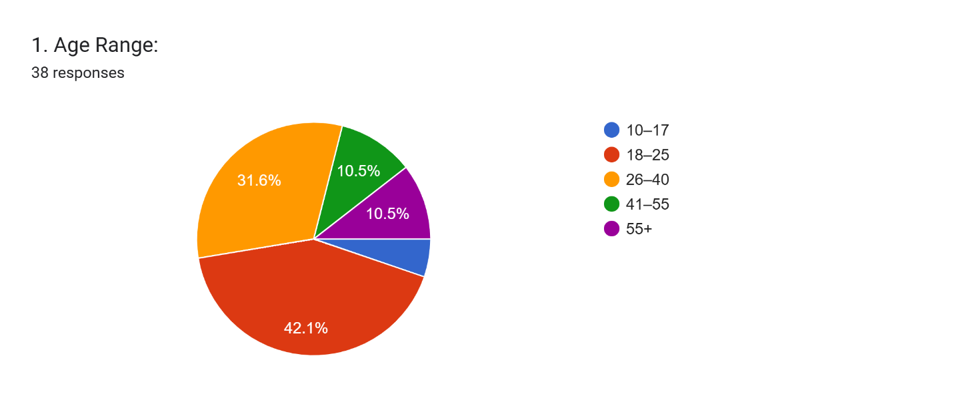

The outcome reveals that the largest group of respondents falls within the **18-25 age range** (42.1%), followed by **26-40** at 31.6%. The **10-17** and **41-55** age groups each represent 10.5%, while **55+** is the smallest group. This age distribution shows a strong engagement from young adults, providing valuable insights for targeting this demographic in our research.

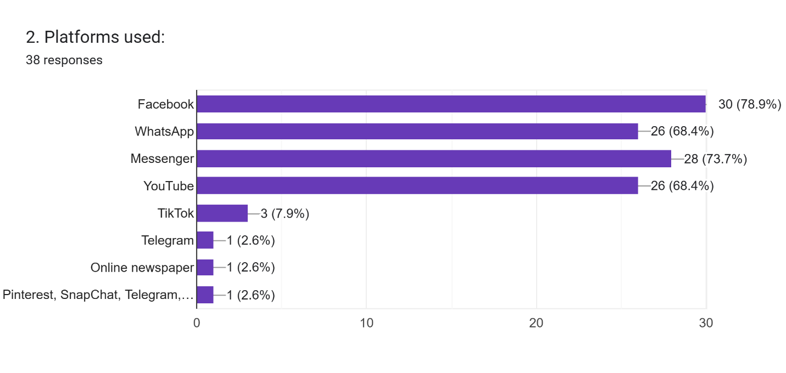

The survey results show that **Facebook, Messenger, WhatsApp, and YouTube** are the most widely used platforms, with Facebook leading at **78.9%**. A smaller portion of users engage on **TikTok**, while platforms like **Telegram, online newspapers, and Pinterest/Snapchat** are used by only a few respondents. This indicates that participants mainly rely on mainstream social media for information and communication.

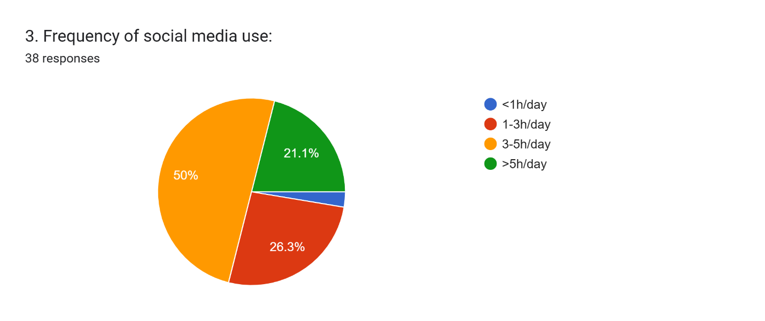

The response about the **frequency of social media use** shows that half of the respondents (50%) use social media for less than 1 hour a day. Around 26.3% use it between 1-3 hours, and 21.1% spend 3-5 hours daily. Only a small portion (2.6%) uses social media for more than 5 hours a day, indicating that the majority have moderate to low usage.

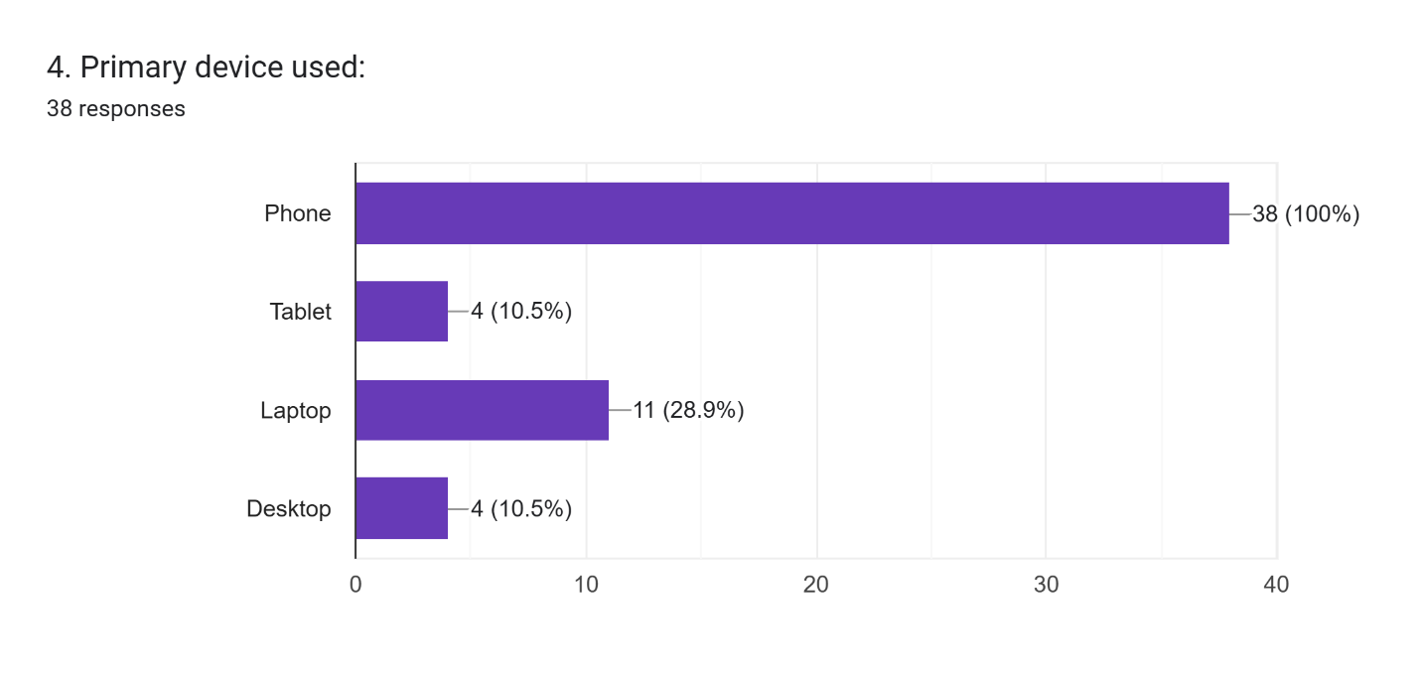

The response about the **primary device used** shows that **100% of respondents** primarily use **phones** for accessing social media. The **tablet**, **laptop**, and **desktop** categories each have very low usage, with only **4 respondents** (10.5%) selecting these options. This highlights the dominance of mobile phones in social media access among the surveyed users.

5. Describe a recent instance when you encountered misleading information online:(38 responses)

The responses reveal common themes of **misleading celebrity death rumors**, **manipulated images**, **fake product giveaways**, and **false political or health-related claims**. Many participants mentioned encountering **scams** or misleading content that caused confusion or panic, especially related to **celebrity deaths** and **fake news**. This highlights the need for a **reliable misinformation detection tool** to address these recurring issues.

6. What is the main difficulty you face when verifying posts?

(38 responses)

The main difficulties users face when verifying posts include challenges with source credibility, conflicting information, and fake links. Many also struggle with the time-consuming nature of verification and lack of tools for quick checks. The increasing sophistication of deepfakes and manipulated content adds to the confusion. These insights highlight the need for a fast,reliable misinformation detection tool.

7. What features should a misinformation-checking tool include?

38 responses

The responses to the about **features a misinformation-checking tool should include** show recurring preferences for:

1. **Multiple verification alerts** and **source authenticity checks** to ensure accuracy.
2. **AI-based tools** for detecting **deepfakes** and manipulated images.
3. Features for **cross-referencing trusted sources** and **context explanations**.
4. A **real-time fact-checking system**, along with **clear notifications** to alert users about false information.

**Common Similarities:**

* Users emphasize the need for **AI tools** to detect **fake content**, with a focus on **image verification** and **source credibility**.
* There is a strong preference for **clear alerts** and **quick verification features** that provide context and source legitimacy.

These insights suggest the need for a tool that integrates **AI verification**, **real-time cross-referencing**, and **trustworthy source analysis**.

8. How would you prefer the tool to notify you about suspicious content?38 responses

The responses about **preferred notifications for suspicious content** reveal a strong preference for **subtle alerts**, such as **small pop-ups** or **colored warning icons**. Many respondents favored a **two-step verification** approach, with **clear explanations** and **links to verified sources**. Others preferred **non-intrusive notifications**, like **red or orange color codes**, or **audio alerts** for accessibility.

**Key Similarities:**

* Users want **quick, non-disruptive notifications** that provide sufficient information to understand the issue without interrupting their browsing experience.
* There is a common interest in **color-coded alerts** (red for fake, orange for likely false), **pop-ups**, or **icons** that indicate suspicious content.

These preferences highlight the need for **subtle, informative alerts** that empower users to verify information without interrupting their user experience.

9. What kind of support or guidance would help you handle fake news better?38 responses

The responses about **support for handling fake news** emphasize the need for **clear, easy-to-follow guidance** such as **step-by-step tutorials**, **fact-checking tools**, and **educational tips**. Many respondents highlighted the importance of **real-time alerts**, **source verification**, and **digital literacy training** to help identify and avoid misinformation effectively.

**Key Similarities:**

* Users want **simple resources** that provide actionable steps for verifying content and recognizing fake news patterns.
* There is a strong demand for **automatic alerts**, **real-time data**, and **reliable tools** to support quick fact-checking.

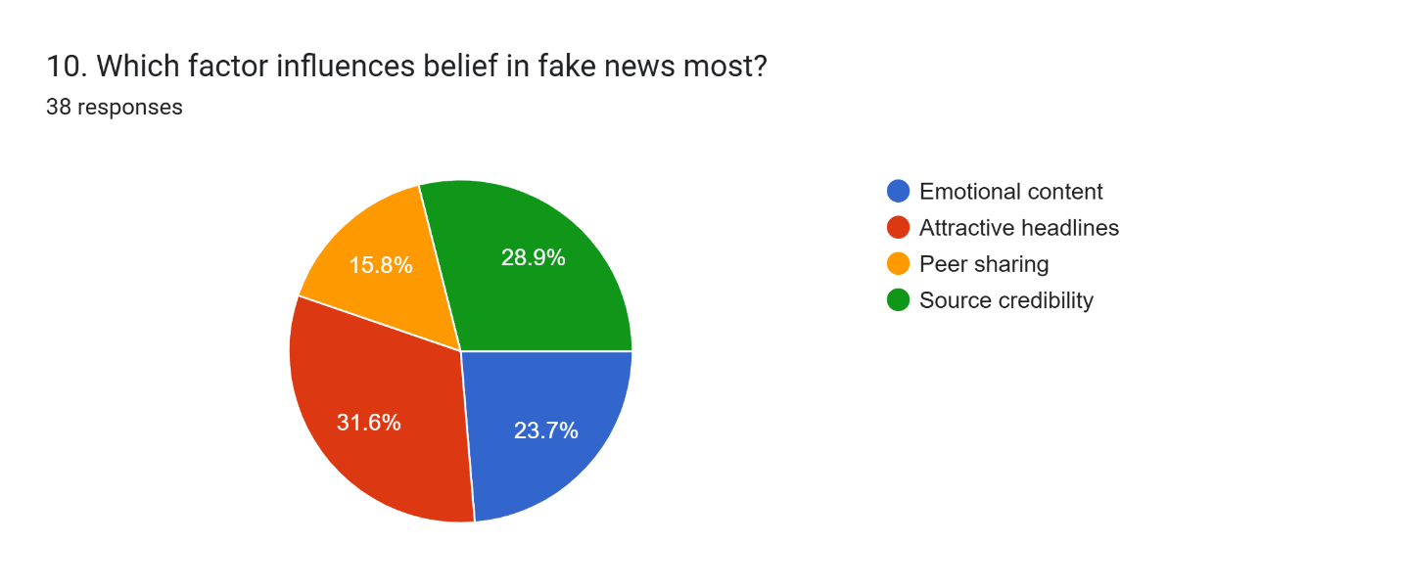

The graph shows that **source credibility** is the most influential factor in believing fake news, with **31.6%** of respondents selecting it. **Attractive headlines** follow closely with **28.9%**, while **emotional content** and **peer sharing** influence beliefs by **23.7%** and **15.8%**, respectively. This indicates that users prioritize the trustworthiness of the source over emotional or sensationalized content.

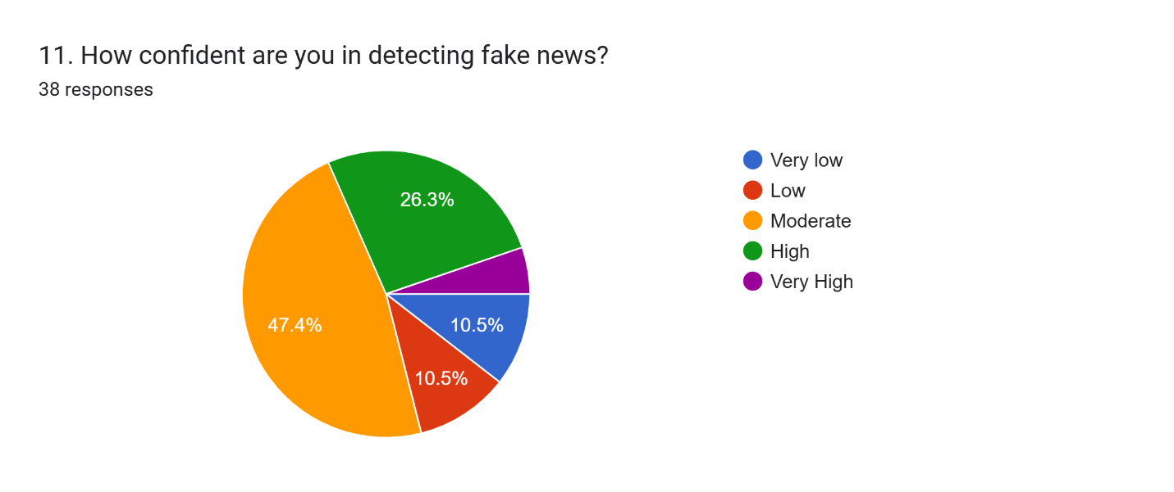

The graph shows that **47.4%** of respondents feel **moderately confident** in detecting fake news, while **26.3%** feel **highly confident.** A smaller portion of participants feel **very low** (10.5%) or **low** (10.5%) confidence. Only **5.3%** are **very high** in their ability to detect fake news. This indicates that most users have a moderate to high level of confidence, but a notable portion still feels unsure.

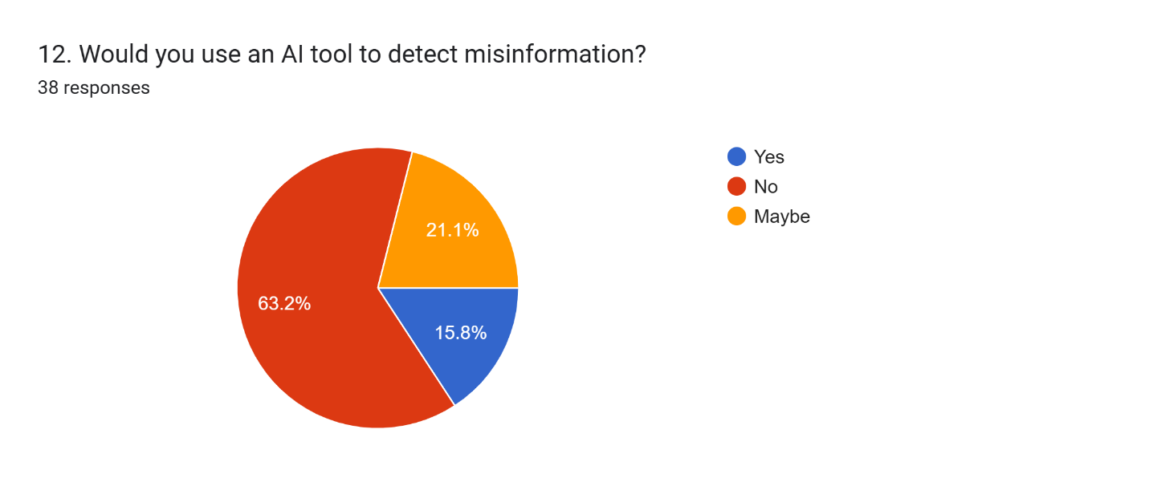

The graph shows that **63.2%** of respondents would use an **AI tool** to detect misinformation, indicating strong interest in AI-powered solutions. **21.1%** are unsure and answered **maybe**, while **15.8%** would not use such a tool. This suggests a generally positive attitude towards AI in misinformation detection.

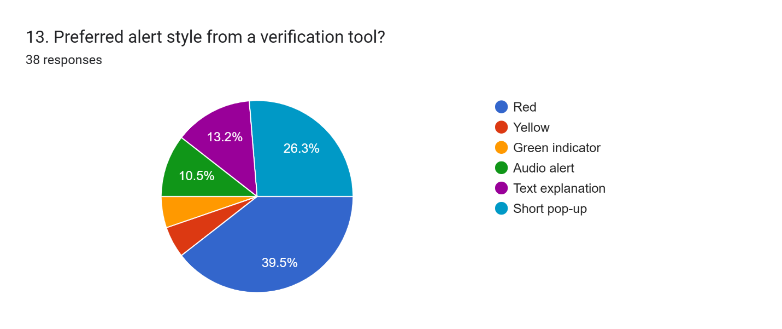

The graph shows that the most preferred alert style from a verification tool is a **short pop-up** (39.5%), followed by a **red alert** (26.3%). **Yellow** and **green indicators** are less preferred, with **text explanations** and **audio alerts** receiving the least amount of preference. This indicates a strong preference for non-intrusive, clear, and visible alerts.

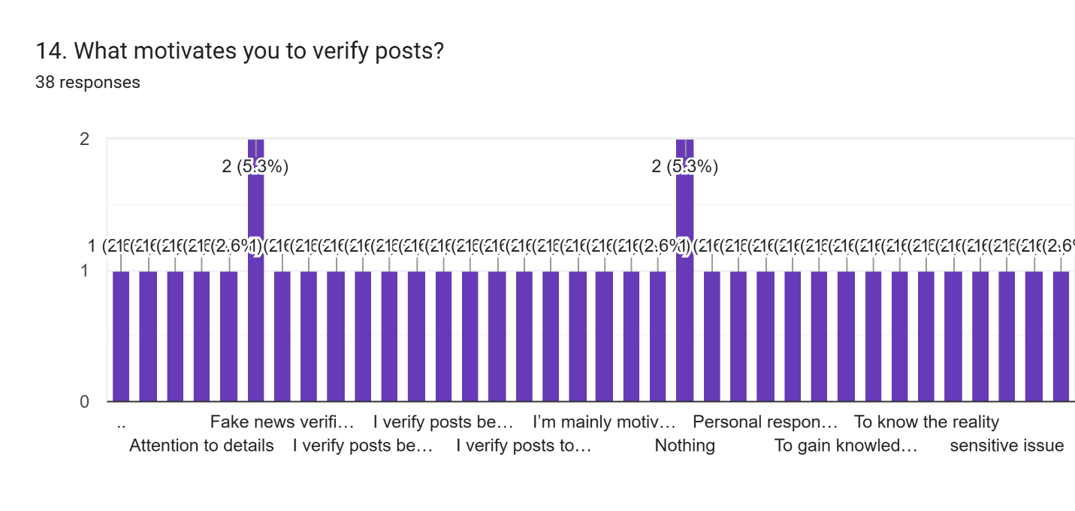

The graph shows that the primary motivations for verifying posts are to **combat fake news** and to **pay attention to details**, with both receiving **5.3%** of responses. The rest of the responses are spread across various motivations, including **personal responsibility**, **gaining knowledge**, and addressing **sensitive issues**, indicating a diverse range of reasons driving users to verify content.

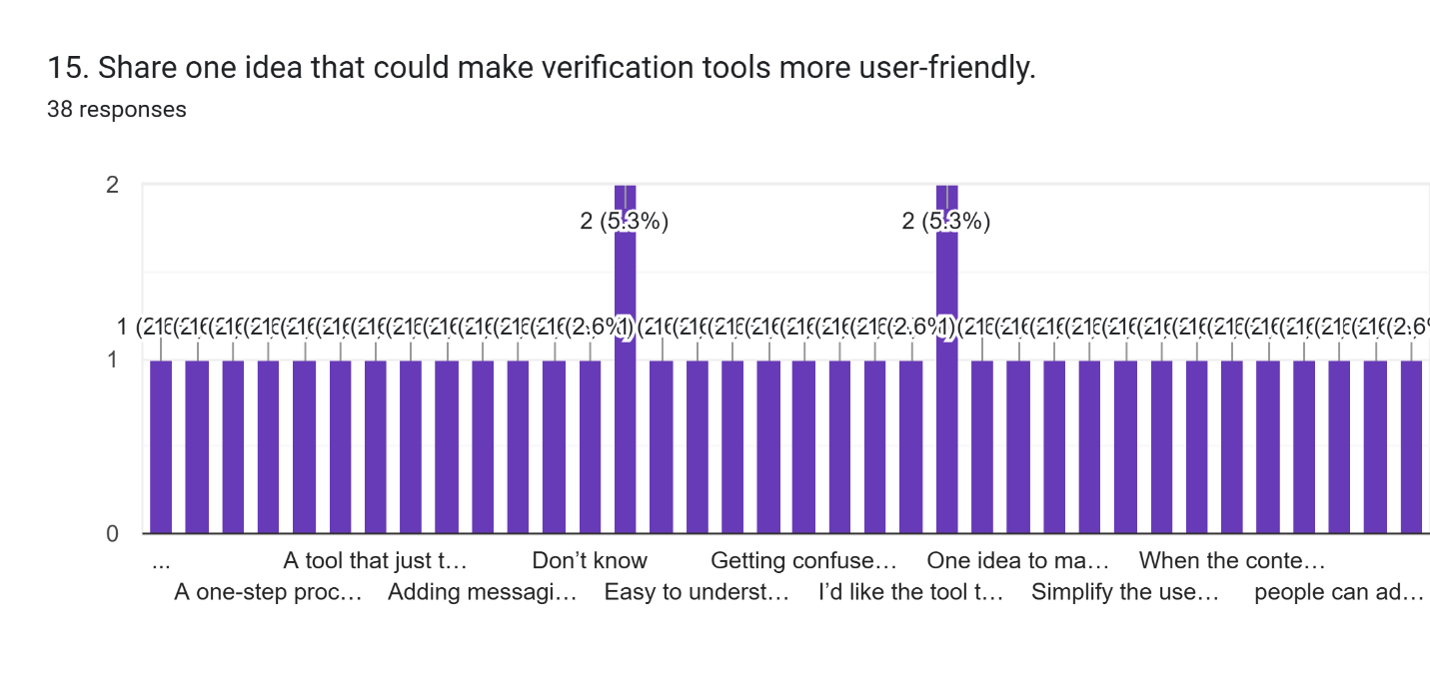

The graph shows that most respondents suggest improving verification tools by making them **simpler and more intuitive**, with **easy-to-understand** features (5.3%). Other responses emphasize the need for a **one-step process** for verification and clearer messaging, indicating a preference for **user-friendly design** that minimizes complexity. The remaining responses focus on providing **real-time explanations** and **simplified alerts** to improve usability.

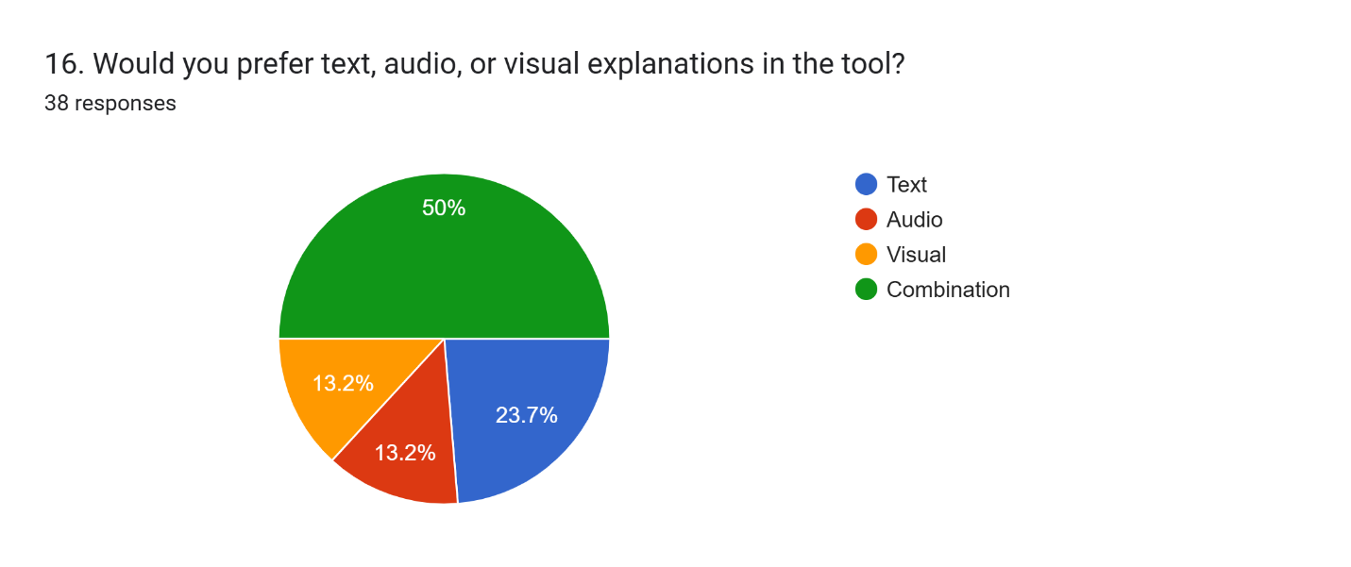

The graph shows that **50%** of respondents prefer a **combination** of text, audio, and visual explanations in a misinformation-checking tool. **23.7%** prefer **visual** explanations, while **13.2%** prefer **text** and **audio** separately. This indicates a strong preference for a **multi-modal** approach that combines different types of explanations.

# **CHAPTER 7 — PRODUCT DEVELOPMENT**

This chapter documents the technologies and components we implemented in our Android misinformation detection system.

## **7.1 Technologies Used**

### **1. Android Java**

We implemented all major components—including MainActivity.java and ShottyoBondhuService.java—using Java.

### **2. Android Accessibility Framework**

Our service_config.xml enables:

* Window content change detection
* Retrieval of on-screen text
* Seamless activation via Accessibility Settings

This powers the core scanning capability of our system.

### **3. WindowManager Overlays**

Our overlays are created by inflating:

* layout_floating_widget.xml
* layout_highlighter.xml

Using parameters such as:

* WindowManager.LayoutParams(
* TYPE_APPLICATION_OVERLAY,
* FLAG_NOT_FOCUSABLE,
* PixelFormat.TRANSLUCENT
* )

This ensures that:

* Overlays float above other apps
* They remain non-intrusive
* They are visually efficient and responsive

### **4. Custom Cyberpunk UI Components**

We designed a strong visual identity using drawable XML files:

* bg_cyberpunk_alert.xml for glowing red alerts
* bg_cyberpunk_card.xml for futuristic system cards
* bg_cyberpunk_button.xml for neon buttons
* border_red.xml for our highlight frame

These create a cohesive cyberpunk look suitable for a warning interface.

## **7.2 System Architecture**

### **MainActivity**

* Displays system status
* Shows Overlay and Accessibility permission states
* Starts our service when all permissions are granted

### **ShottyoBondhuService**

* Extracts on-screen text
* Renders our floating cyberpunk alert widget
* Displays the red highlighter overlay
* Contains placeholders for ML-based detection

### **Overlay Manager (Inside the Service)**

* Creates, positions, and displays overlays
* Handles alert dismissal events

### **Detection Layer (To Be Integrated)**

Our service currently has placeholders where we will later integrate:

* Keyword detectors
* A TFLite classifier
* Rule-based decision logic

### **Feedback System (Planned)**

We intend to add:

* User confirmation buttons
* Logs to improve detection accuracy

## **7.3 Model Integration**

Our detection pipeline is already prepared for ML integration.  
We plan to incorporate:

* A TFLite misinformation classifier
* Probability decision thresholds
* Output results displayed through the floating widget

This setup offers:

* Enhanced privacy
* Offline functionality
* Low-latency inference

## **7.4 Development Progress**

|  |  |
| --- | --- |
| **Component** | **Status** |
| AccessibilityService | ✔ Configured via service_config.xml |
| Overlay UI | ✔ Floating widget + highlighter are working |
| MainActivity | ✔ Permission dashboard completed |
| Design System | ✔ All cyberpunk drawables & themes integrated |
| ML Model | ✖ Pending integration |
| Server backend | Optional for future expansion |

# **CHAPTER 8 — CONCLUSION**

## **Learnings**

Throughout this project, we learned several important lessons:

* Accessibility services require careful UX and ethical consideration.  
  Implementing ShottyoBondhuService helped us understand how sensitive these permissions are and how essential transparency is.
* Overlays must be impactful yet unobtrusive.  
  Our cyberpunk-inspired UI taught us how to balance visual strength with usability.
* System-level permissions are a major HCI design challenge.  
  Designing our permission dashboard improved our understanding of user onboarding for complex Android features.

Real-time detection requires optimized pipelines.  
Our architecture is now capable of supporting low-latency ML inference, and we gained practical knowledge about performance constraints.

## **Limitations**

* No ML model integrated yet
* Highlighter currently highlights the full screen instead of precise regions
* Certain apps may conflict with overlay layers
* AccessibilityService may consume noticeable battery power
* Only English UI and detection supported at this stage

## **Future Plan**

* Integrate a TFLite misinformation classifier into onAccessibilityEvent()
* Add bounding-box detection for precise text-specific highlighting
* Expand alert UI with credibility scores and fact-check snippets
* Create a settings panel for sensitivity and customization
* Add Bangla support and train multilingual models
* Implement a privacy dashboard explaining text processing
* Conduct formal user testing based on Nielsen’s heuristics